Rhythmix

Introduction

Background, Objectives and Deliverables
Background
The inspiration for this game came from the arcade game Maimai where the screen is a large circle with eight buttons around it that the player must press when the notes approach the hit area (the place that the notes must reach before the button is pressed). However, with this game being limited to arcade machines and not many of them around lots of people are unable to experience the game. Although there is an unofficial version that can be run on a PC it requires a touchscreen monitor which many people do not have and comes with the risk of damaging the monitor if someone is playing a fast or difficult level.

The Persona Dancing games share the similarity of having a circular play area where notes spawn in the centre of the play area and move outwards towards the hit area. Unlike Maimai the Persona Dancing games are on PlayStation which allows a larger audience to play them and they also have a story that ties into the corresponding persona main line game. They also have different costumes for the characters which the player can equip that will make the gameplay easier or harder.

This project will deliver a complete game made in Unity that runs on Windows. The final build will not contain an errors that cause the game to crash or severely affect the players experience in any way. The game should be able to run on low end systems that have a dedicated graphics card with a target of at least 60 frames per second on capable computers. Instead of having one large circle as the play area like the previous examples there will be a left and a right circle with the left circle using the controllers D-pad inputs and the right one using the ABXY buttons (Xbox controller).

Objectives
- The player will be able to choose a level to play and use a controller for the inputs during the level
- There should be both tap notes and hold notes in the gameplay
- If a player completes a level they should see a results screen at the end which displays all the information about the score they just set
- If a player sets a high score the score should be submitted to the global leaderboard for that map
- When choosing a song the player should be able to press on a level and see the top 25 players on the global leaderboard for that map
- Players should be able to create their own levels in the level editor by adding their own songs and adding in notes where they want
- The level editor should be able to load a level into it and make changes to the level

Deliverables
A minimum viable product should include most if not all of the objectives mentioned above and they should not have any issues that severely impact the players experience. Deliverables for this include:
- Allowing players to play levels using a controller, submit scores to the leaderboard and see the top 25 players on each level
- A level editor where players can add their own songs and add hold and tap notes where they would like

Method of Approach
Agile Development Cycle
This project used an agile development cycle due to its advantages in flexibility and how tasks are broken down into smaller sub tasks instead of one large goal to reach far off into the future. If this project was to be made for a client this would allow me to show them progress every two weeks and keep them informed on what has been done and what will be done next. It would also allow clients some more time to change their mind before committing to an idea as the direction of development can be changed quicker compared to other software development cycles.
Using Trello to manage the sprints meant that I could plan future sprints many weeks before hand and because of the flexibility of and agile approach that meant that future sprint plans could be changed easily without causing any major issues.
Risk Plan

Tools and Technologies
Microsoft Visual Studio 2022
Microsoft Visual Studio was used as the code editor due to having precious experience as well as having it already setup with Unity from previous projects. This was chosen over Microsoft Visual Studio Code because to set it up more packages had to be downloaded for Unity and extensions had to be added I Visual Studio Code. I did not want to have any more packages than needed in Unity as many of them can cause conflicts that take up a lot of time to resolve so choosing not to use it skips all of those problems.

Unity 6000.2.10f1
I chose to use Unity over game engines like Unreal Engine as it is purely a 2D game so creating a project in Unreal Engine would overcomplicate it. Also Unreal Engine can have very long load times when opening the project or even the executable. Another option was to use Godot but since I have no experience in using it I would have to learn how to use the game engine for some time before I could start to make good progress on the project.

PlayFab
PlayFab is a service from Microsoft that can handle many things about an online game including player accounts, cloud code, ads, currency and leaderboards. I have used it to create anonymous accounts with a display name and its leaderboards service to allow players to compete against each other on the same level. Another option that could have been used was Unity’s leaderboards system, however they do not allow a client to create a new leaderboard and even if you use metadata as a leaderboard ID a player can only have one score on one map. As well as this it has a free plan that has a limited number of API calls. The number of calls and the timeframe differ depending on what API feature you are calling.

Trello
Trello was the tool used to manage the project. This included creating a project backlog for all of the future tasks that needed to be completed, planning current and future sprints and keeping track of progress to ensure that I don’t fall behind.

Notepad
Notepad was used when testing and debugging the level editor. This is because the level editor saves information to a text file so using notepad, I can see exactly what was written to the file. I could also make any manual changes I wanted when debugging and testing to ensure the game was reading and writing to it correctly.

Project Management
Sprint Plan

Version Control
Version control was extremely important during the development process due to being able to add small changes, undo and local changes that caused the game to break or even to share it across different devices. If any files were lost or incorrect changes were made using version control allowed me to recover a previous version without any of the unwanted changes added into the project. Since version control also allows you to access it from other devices this was useful to continue working on the project on my laptop or the computers in the university.
For this project I chose to use GitHub since it was something I was familiar with through usage in other modules. The only limitation that caused issues was GitHub’s 50mb commit limit when creating the initial repository for the project as the Unity project was fairly large. Whenever changes were made and appeared to be working in the way that was expected they were committed to the repository so they could be accessed from other devices and as a backup in case the local files were lost.

Implementation
Gameplay
In the gameplay scene the places the notes spawn and move along have been split into eight different lanes. Each lane has its own list of tap notes and hold notes that it must create. I chose to have eight individual lanes as this means that there can be multiple notes that have the same hit time and won’t conflict with each other. When a level is loaded each lane reads the file that contains the note data and adds the timestamps needed to a list for either tap note or hold notes.
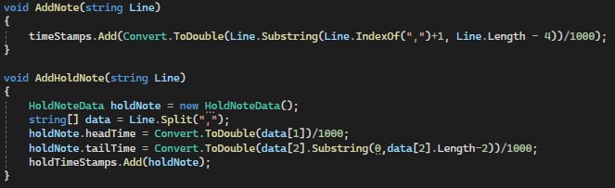
Since the level file has all the notes in order by the timestamp that means the lists containing the timestamps are in order as well so when creating the notes for the gameplay the lane starts from the beginning of the list and works its way towards the end. When each lane has no notes left to create the results screen is shown to the player so they can see how well they performed.

Getting the Notes to Move
This is one of the most important parts of the gameplay. In order to get the notes to move I decided to tie their position to the current time of the song. Using this I gave it a point that it should reach when the note timestamp and the song time are equal. This point is the correct part of the hit area for the lane that the note was spawned in.
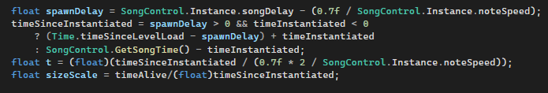
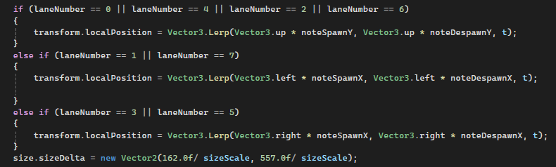
The size of the note is also tied to the song time. This is because if the notes were their full size when spawned in the centre of one of the circles they would overlap and cause the player to be unable to understand what they were seeing. Using the calculation above the notes reach their full size when they get to the hit area.

Handling Controller Axis vs Button Inputs
With the controls for the gameplay using the D-pad and the XYAB buttons on the Xbox controller that meant that lanes 0-3 had to be treated differently from lanes 4-7. This is because lanes 0-3 use the D-pad for their inputs and the D-pad uses an axis for its inputs instead of normal button inputs. This means that it uses values between -1 and 1 to indicate which direction has been pressed. An input higher than 0 on the X axis means the right D-pad button has been pressed and an on the Y axis it means that the up D-pad button has been pressed. If it is less than 0 that means on the X axis the left D-pad button has been pressed and on the Y axis it means the down D-pad button has been pressed. If the input is equal to zero it means that no button has been pressed.

Hold Notes and Tap Notes
Tap notes were the simpler type to implement as the game only needs to recognise when a button has been pressed. This was done with the Input.GetKeyDown() method in Unity for the ABXY buttons and checking the D-pad axis using Input.GetAxis(). The hit error of the player is the difference between the time the player hit the note and the timestamp of the note which is used for giving the player a score.
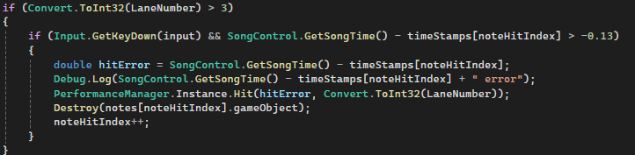
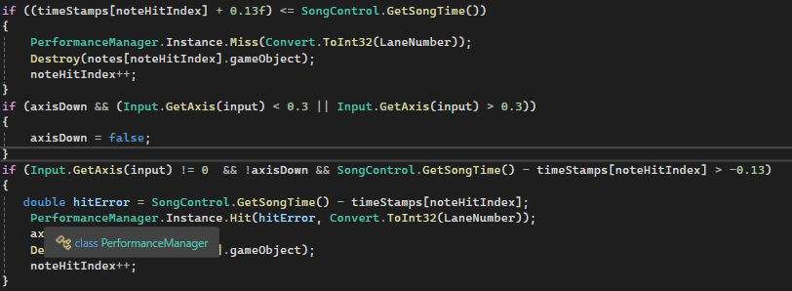
For hold notes the game checks for when the player presses the button down when the head of the hold note approaches the hit area and when the tail approaches it the game checks for when the player releases that same button. On both the head and the tail the player is given a judgement rewarding them with the appropriate number of points and accuracy. Instead of repeatedly checking if the player is holding down the button the game just checks for the initial press of the button. Then if the player releases the button, it checks their timing for the tail. The head time is checked before doing anything to do with releasing the button as if the player had just it a tap note and released the button then the game would check the tail time of the hold note and destroy it giving the player a miss judgement even though they were not interacting with the hold note.
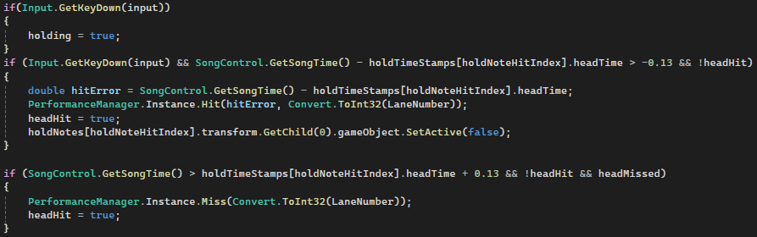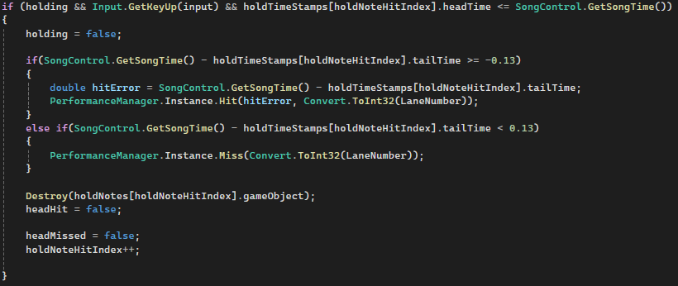

Gameplay Statistics:
When playing the game the player is given different judgements. These are ‘Perfect!’, ‘Great!’, ‘Ok’ and ‘Miss’. Each of these judgements are based off how accurate the player was to having perfect timing on hitting the note.
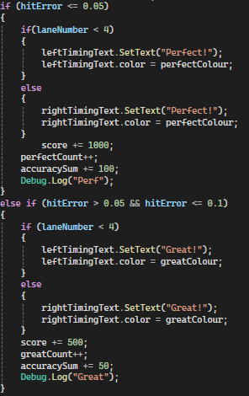
The score the player gets at the end is used to determine their position on the global leaderboards, the accuracy shows the player how far or close they were to having perfect timing on every note in the level and the max combo is used to tell the player their largest amount of notes they hit I a row without missing.
At the end of the level the player is shown a results screen where they can see all the information about the map. This includes their score, accuracy, highest combo and number of each judgement type. The results screen also allows the player to leave the level and return to the song select scene or they can play again. If they choose to play again instead of resetting everything in the scene it just reloads the same scene again using the same information about what level to play.
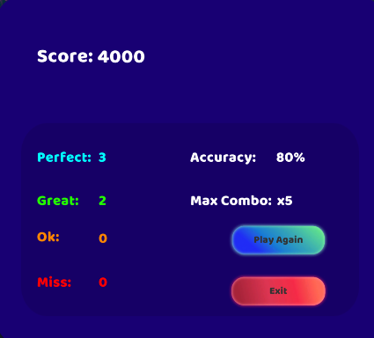

Choosing a Song to Play
In the song select scene if the player has just opened it from the main menu the first song will be selected by default. This will be indicated by the toggle that represents that song being larger that the others in the list. When clicking on a level in the list the game will scroll up or down so that the selected level is in the middle of the screen. In some cases where this is not possible such as being at the start or end of the list the scroll view scrolls as far as it can so that it does not try to put it in the middle of the screen and then ping back to the top/bottom.
Players can also see the leaderboard of the map they clicked on. This is updated every 0.5 seconds to limit API calls but this also means that it shows any new scores set by other players shortly after they are submitted to the leaderboard.
When the play button is pressed the name of the song and the sibling index of the toggle are saved in the varsToPass script. The song is saved so that the gameplay scene knows which files to look for and the sibling index is saved so that when the player returns to the song select scene the level they were just playing is toggled on and in the middle of the screen.

Level Editor
When the player opens the level editor for the first time they will be asked if they want to see the instructions on how to use it. This will explain to them what they need to do to setup a level, how to add notes and how to save the level.
Setup
To setup a level the player is shown a screen where they can add a song, choose the BPM of the level and choose the beat division they would like the level to be in. When they add a song the file explorer window limits them to adding mp3 files. This is to means that the file type that they choose does not need to be checked when they are finished. The BPM of the song is needed so that when creating the timing lines the player does not have to find the perfect timing themselves and instead it is given to them. For performance reasons the minimum number of timing lines are created and each timing line can represent different timings as when they reach the end of their lane they are moved back to the centre and are hidden until all the other timing lines have looped around. If it was not done this way tens of thousands of unique timing lines would be needed and that would not be possible to run even on the best of computers.
Timing Lines and Adding Notes
When the initial setup has been completed the timing lines will be added to each lane. Each of these timing lines are clickable which allows the player to add the notes. When a note is added to a timing line if it is a tap note the timing line adds its current timestamp to a list for tap notes. If it is a hold note it creates an object from a class called HoldNoteData. This class has both the head time and the tail time of the timestamp but the player must add both the head and the tail to the level first before the object is added to a list of objects that contain other HoldNoteData objects. If a timing line has a note attached to it and the player clicks it again this destroys the note and removes the timestamp from the list of tap or hold notes. This also removes the problem of having two notes in the same lane having the same timestamp as when the game checks what to do it will add a note if the timing line does have a child or will destroy its child if it has one.
Saving the Level
When saving the level a new script runs which loops through all the timing lines and adds all of its tap notes and hold notes into two new lists. Then it sorts the tap notes by timestamp from lowest to highest and the same with the hold notes using the head timestamp. These lists are made out of objects from two new classes. These classes contain the same data from the lists of the timing lines but also include the lane number as well because this is important information needed when loading the notes in the gameplay. Then it writes to the level file but checks if the timestamp of the next note to write from both lists and writes the smallest one. They are written from smallest to highest because in the gameplay scene the notes will be added to the correct lane in the correct order. If for example a note with a timestamp of 1000ms was first in a list that had another timestamp of 500ms after it then the 500ms note would only be spawned on after the 1000ms note was spawned in. Since notes get destroyed if the time the song has been playing is 130ms larger than the timestamp of the note it would be spawned in immediately be destroyed as well as giving the player a miss judgement. The beat per minute of the song is also written at the end under #MapData which is used when loading a level in the level editor.
Loading a Level
Players are also given the choice to load a level so they can edit it. Once the player has chosen the file of the level they would like to edit the timing lines each check all the notes in the file. First checking for the lane number and then seeing if at some point they will have the same timestamp as the note. If they will have the same timestamp at some point it will be added to the timing lines list of timestamp and will be created when the timing lines timestamp is equal to the notes timestamp. This means that players do not have to create a whole level in one go and instead can save their changes and come back another time.

Leaderboards
To add leaderboards to the game I chose to use PlayFab. The first part I had to do was to be able to create leaderboards for each player made level. However with PlayFab all you have to do is submit a score to a leaderboard using a leaderboard ID and if it does not exist it will create one. This meant that next I had to find a way for player made levels to have a unique ID. This was done by creating a timestamp of when the player who made the level chose to submit their level to be given a leaderboard and storing it in the file containing the level data.
When submitting a score the game must first retrieve any scores the player has made to that level and check if it is higher than the score they just set. If it is higher then the score is not submitted to the leaderboard but if it is the old one will be removed and the new one will be added. Although there is an option on PlayFab to have it only update scores by highest score for each player this must be done manually for each leaderboard which is not a feasible option should many levels be made.
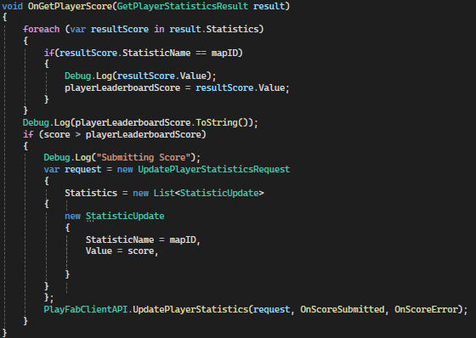

File Structure for Levels
In order to play levels I have created text files that store all the information about the level. Below is an example of what it looks like:
1,749.9999:0
4,6150,6350:1

#MapData
BPM:100
LeaderboardID:639111095584340343

The first number of each line represents the lane that the note is to be created in. If the number at the end after the ‘:’ is a 0 that indicates it is a tap note below shows what each number means for a tap note:
laneNumber,hitTime:noteType
Here ‘hitTime’ shows what time the player should press the button that corresponds to the lane it is in. The time is stores in milliseconds.

If the number after the ‘:’ if a 1 then that means it is a hold note. Below shows what each number means for a hold note:
laneNumber,headHitTime,tailHitTime:noteType
‘headHitTime’ refers to the time the player must press down on the button for the corresponding lane and ‘tailHitTime’ refers to when the player must release that button.

Lastly everything after ‘#MapData’ contains other information needed about the map. ‘BPM’ is the beats per minute of the song. This is used in the level editor to create the timing lines that are needed to show where the player can add notes to the level. ‘LeaderboardID’ is the timestamp that the player who created the level submitted it to be added to the leaderboards. This is then used when a player completes a level to submit their score to the global leaderboards.

Legal, Ethical, Social and Professional Issues
Legal
A legal consideration I must make is the use of music. The music included in the game by default must not contain any copywritten material and I must not provide any way to distribute the music added by players creating levels themselves or encourage it. If I were to distribute the music myself this could lead to the game being taken down and even lawsuits with the affected artists or their music labels.
Another legal consideration is collecting user data. I have chosen not to collect their data and instead use an anonymous sign in through PlayFab to avoid these issues. This means that I only store a playerID which is used for submitting scores to the leaderboard and no other data.

Ethical
An ethical consideration is not getting players too addicted to the game. Although the point of developing a game is to make something people want to play you should not create a something that causes people to play too much that it affects other aspects of their life.
An ethical consideration about sharing music is that the artist will not get paid when players listen to a song through the game unlike how they do get paid when their music is streamed through apps like Spotify and YouTube. This also discourages me from providing a place for players to share music besides the possible legal repercussions.

Social

Professional

Conclusion

